PRACTICAL 9
- Implement a file copy utility using low-level Linux file I/O system calls (open, read, write, lseek, close). Compare its performance with standard library functions (fopen, fread, fwrite).

Develop a program that redirects standard input and output using file descriptors and dup2(). Demonstrate how shells implement I/O redirection
SOL:-
1.File_copy.c
#include <stdio.h>
#include <stdlib.h>
#include <fcntl.h>
#include <unistd.h>
#include <string.h>

#define BUF_SIZE 1024

// Low-level copy using open/read/write
void copy_lowlevel(const char *src, const char *dest) {
int in_fd = open(src, O_RDONLY);
if (in_fd < 0) { perror("open src"); exit(1); }

int out_fd = open(dest, O_WRONLY | O_CREAT | O_TRUNC, 0644);
if (out_fd < 0) { perror("open dest"); close(in_fd); exit(1); }

char buf[BUF_SIZE];
ssize_t bytes;
while ((bytes = read(in_fd, buf, BUF_SIZE)) > 0) {
if (write(out_fd, buf, bytes) != bytes) {
perror("write"); close(in_fd); close(out_fd); exit(1);
}
}

close(in_fd);
close(out_fd);
}

// Standard library copy using fopen/fread/fwrite
void copy_stdlib(const char *src, const char *dest) {
FILE *in = fopen(src, "rb");
if (!in) { perror("fopen src"); exit(1); }

FILE *out = fopen(dest, "wb");
if (!out) { perror("fopen dest"); fclose(in); exit(1); }

char buf[BUF_SIZE];
size_t bytes;
while ((bytes = fread(buf, 1, BUF_SIZE, in)) > 0) {
fwrite(buf, 1, bytes, out);
}

fclose(in);
fclose(out);
}

int main() {
printf("Copying with low-level I/O...\n");
copy_lowlevel("input.txt", "copy_low.txt");

printf("Copying with stdlib I/O...\n");
copy_stdlib("input.txt", "copy_std.txt");

printf("Done. Compare copy_low.txt and copy_std.txt.\n");
return 0;
}
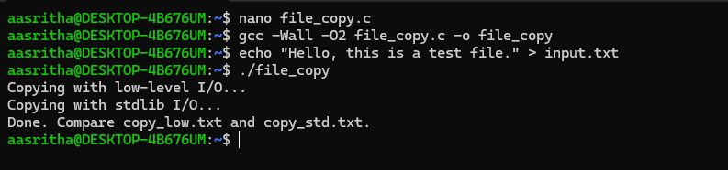
2) redirect.c
#include <stdio.h>
#include <stdlib.h>
#include <unistd.h>
#include <fcntl.h>

int main() {
int in_fd = open("input.txt", O_RDONLY);
if (in_fd < 0) { perror("open input"); exit(1); }

int out_fd = open("output.txt", O_WRONLY | O_CREAT | O_TRUNC, 0644);
if (out_fd < 0) { perror("open output"); close(in_fd); exit(1); }

// Redirect stdin to input.txt
if (dup2(in_fd, STDIN_FILENO) < 0) { perror("dup2 stdin"); exit(1); }

// Redirect stdout to output.txt
if (dup2(out_fd, STDOUT_FILENO) < 0) { perror("dup2 stdout"); exit(1); }

close(in_fd);
close(out_fd);

// Now reading from stdin actually reads input.txt
// And writing to stdout actually writes to output.txt
char buf[256];
while (fgets(buf, sizeof(buf), stdin)) {
printf("Read line: %s", buf);
}

return 0;
}
